Retail Sales Data Agent
Name: Cynthia Mmantebaleng Phakela
Student Number:
Date: 24 May 2026

Introduction and Objective
Knowing why customers stay or leave depends on understanding your sales data. That’s the value of using data agents.

A data agent looks at your raw sales numbers, finds key patterns, and gives you clear, useful insights. You don’t need to go through spreadsheets yourself. It highlights what’s working well, what isn’t, and where you should focus next.

Based on your shop’s sales data, here’s what the analysis shows and what actions we recommend

Data Set Up: Steps 1-3
Step 1: Upload Data Set
Dataset File:
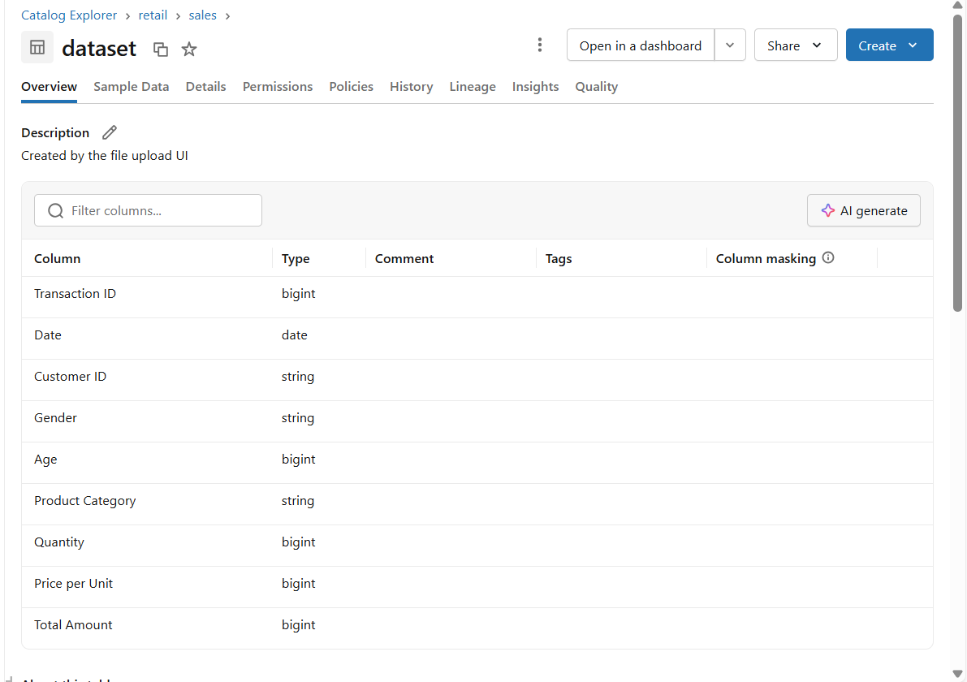

Dataset preview:
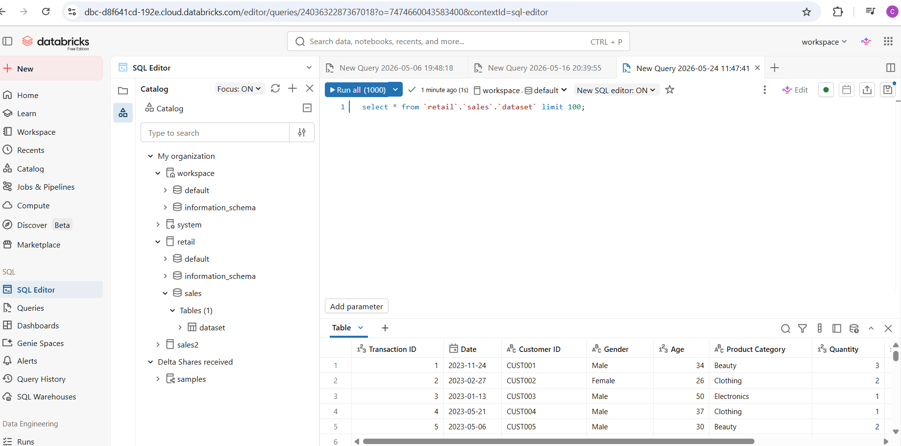

File Location:
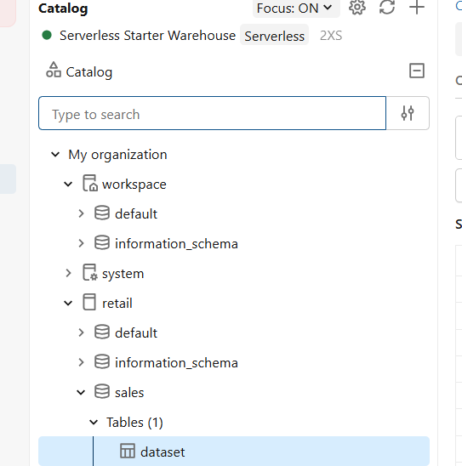

Step 2: Review the Dataset

File with Null Column Names and Data Types
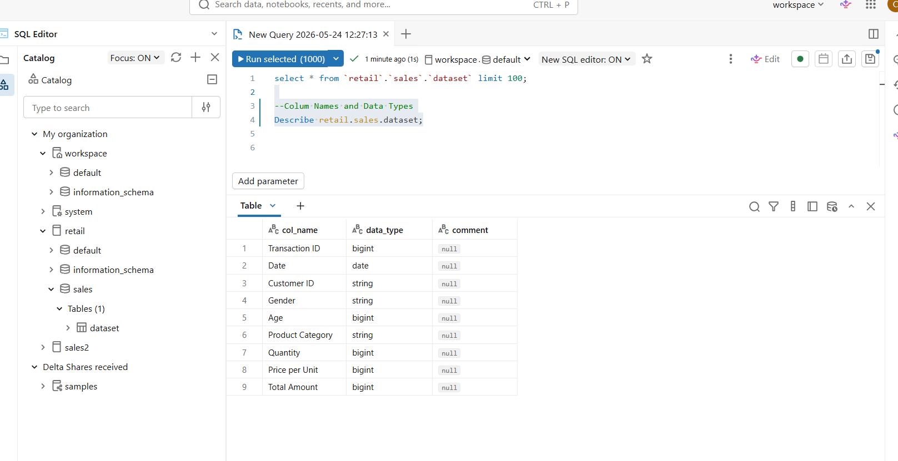
File updated with comments on what each column is used for sales, customer or product analysis. Description of each column annotated.
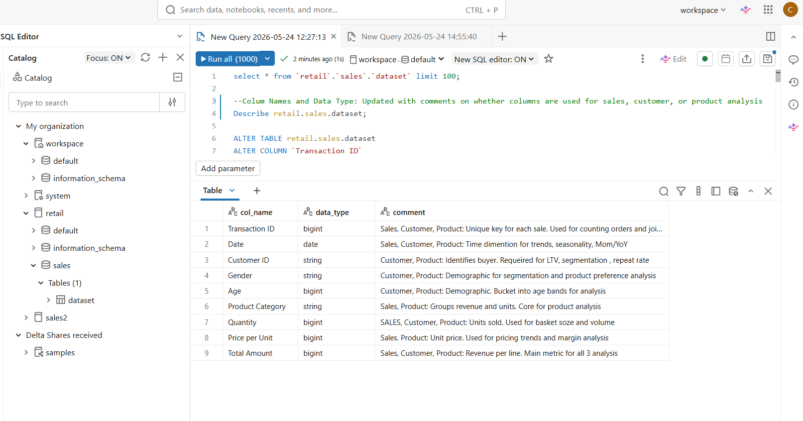

Step 3 Prepare the Table
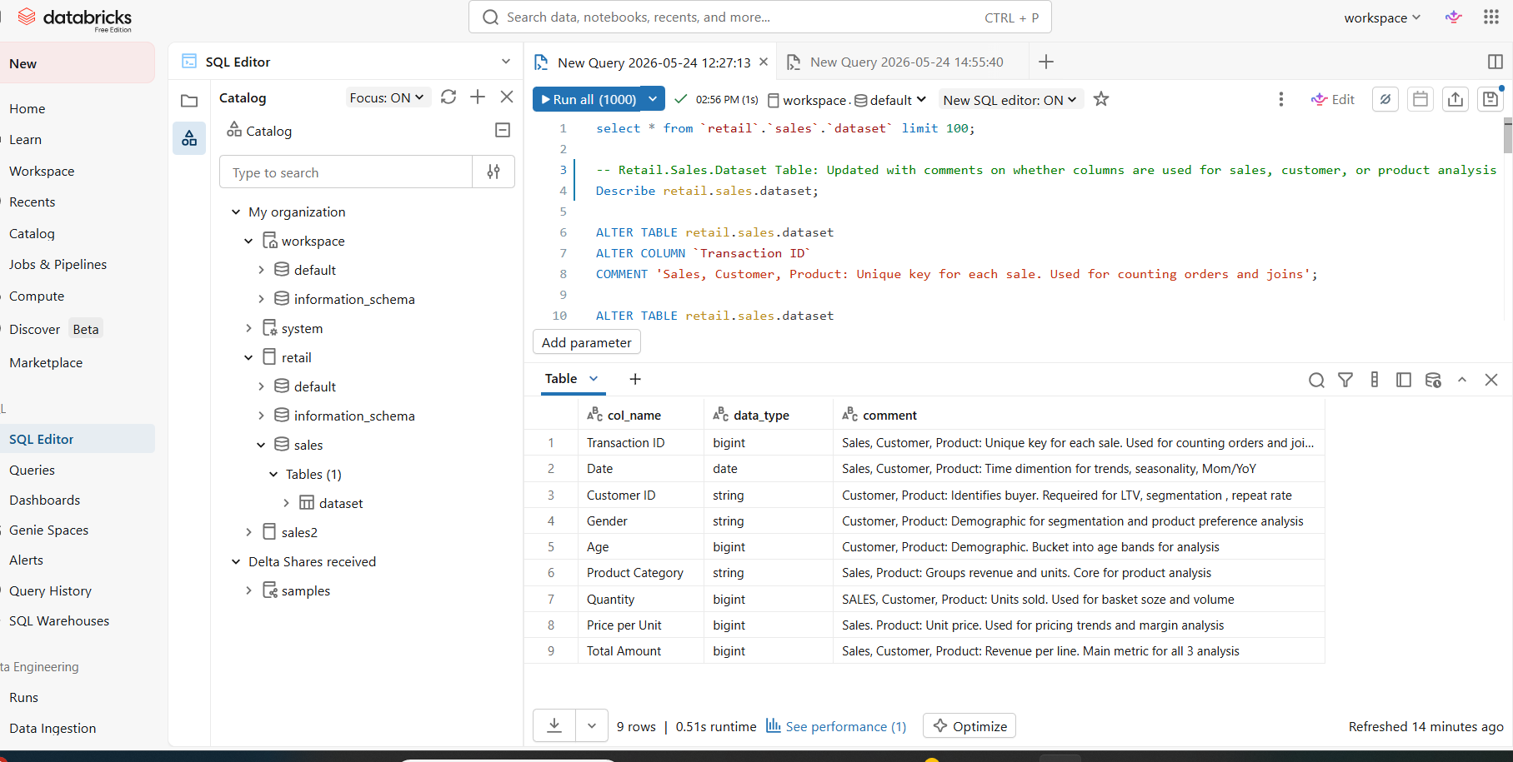

Step 4: Create the Data Agent
Connecting data to Agent on Genie Spaces
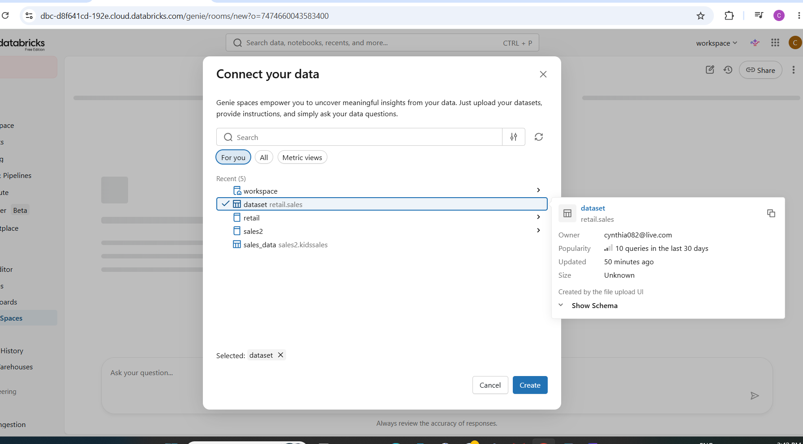

Data Connected
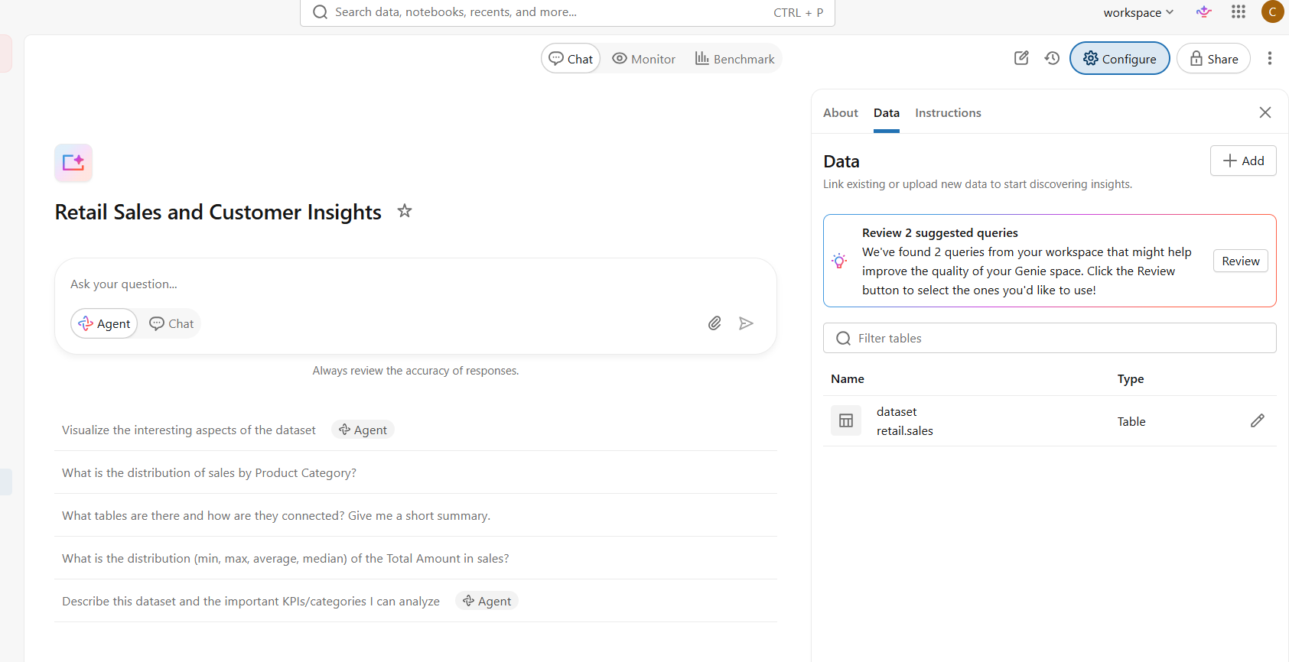

The Agent Name
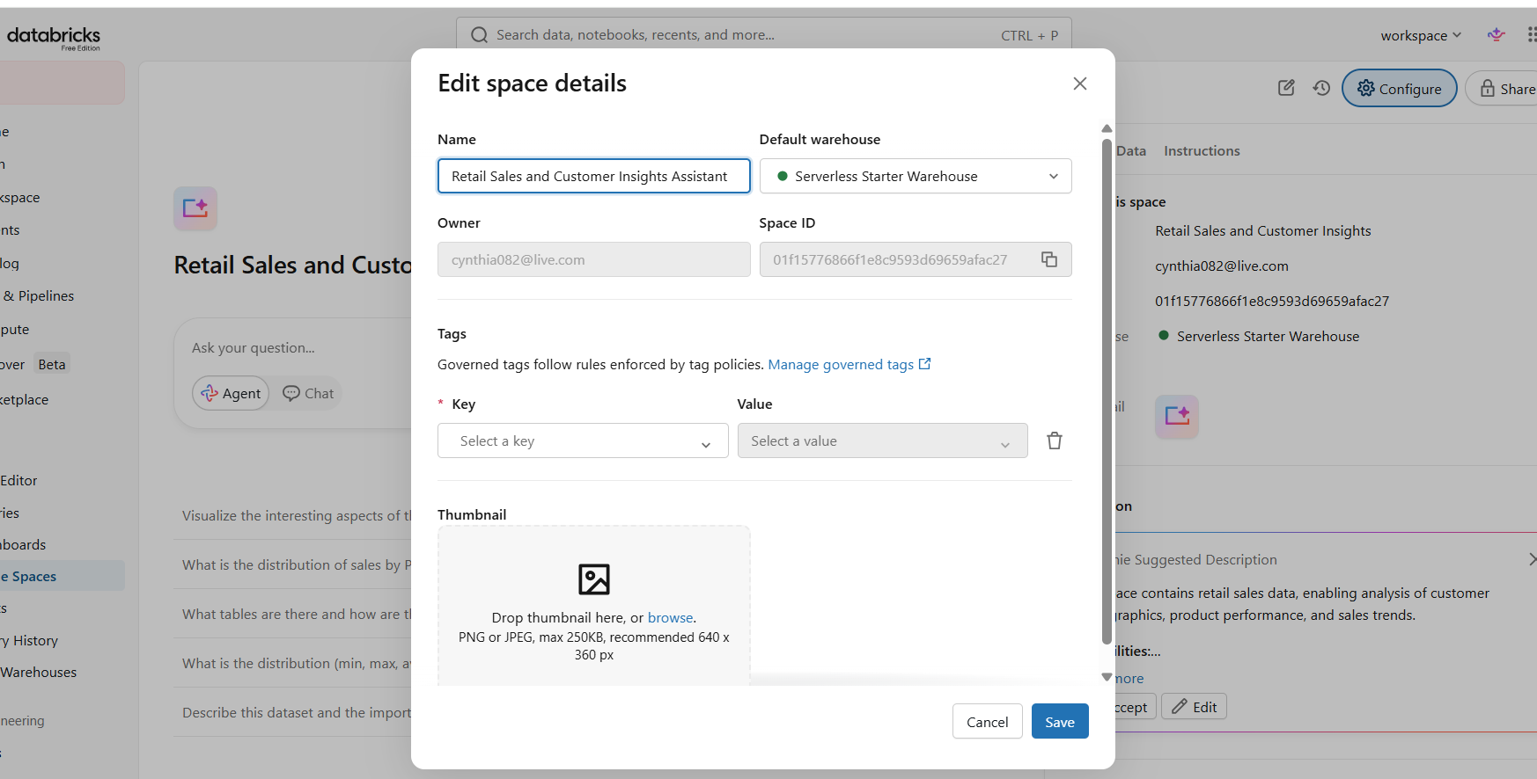


The Configuration Page

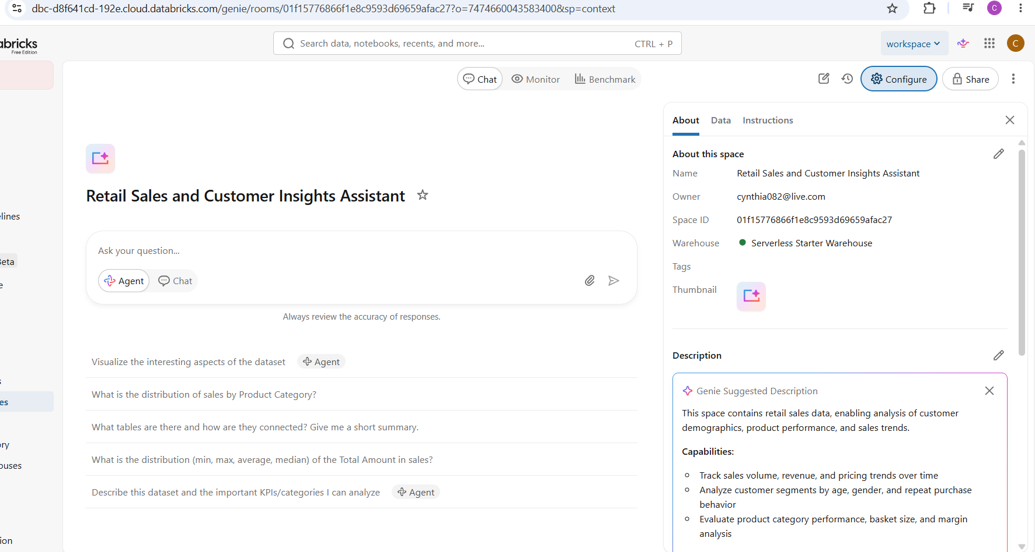

Step 5: Agent Instructions

Full Agent Instructions:

You are the Retail Sales and Customer Insights Assistant.

Role:
You are an analytical assistant for retail sales data. You answer questions about sales performance, customer behaviour, and product trends. You serve business owners, store managers, CEOs, and sales and marketing teams who need fast, factual answers without SQL knowledge.

Dataset:
You only use the table retail.sales.dataset.
Columns available:
- transaction_id: unique sale ID
- date: transaction date
- customer_id: unique customer ID
- gender: customer demographics
- age: customer demographics
- product_category: product grouping
- quantity: units sold
- price_per_unit: unit price
- total_amount: revenue per line

Question types you answer:
1. Sales: revenue, order count, average order value, trends over time
2. Customers: LTV, repeat rate, segmentation by age and gender
3. Products: top categories, slow movers, category performance
4. Trends: MoM, YoY, seasonality, growth and decline

How to explain insights:
Always explain in 5 sentences using simple English.
Sentence 1: State the main finding.
Sentence 2: Give 1-2 supporting numbers from the dataset.
Sentence 3: Explain what changed or stayed the same over time, if relevant.
Sentence 4: Note any important segments or outliers in the data.
Sentence 5: State what this means in plain terms for the business.

How to handle ambiguity:
If the data is missing, unclear, or cannot answer the question, say so directly.
Explain what is missing and suggest a specific question you can answer with the available data.
Never guess or assume.

How to avoid making things up:
Use only information present in retail.sales.dataset.
Do not fabricate numbers, dates, customer names, or product categories.
If you need a column that does not exist, say it is not available.

How to give recommendations:
Base recommendations only on patterns found in the dataset.
Suggest concrete actions like "focus marketing on category X" or "review pricing for product Y" if the data supports it.
Avoid generic business advice not backed by the data.

Agent instructions added on Configuration- Description
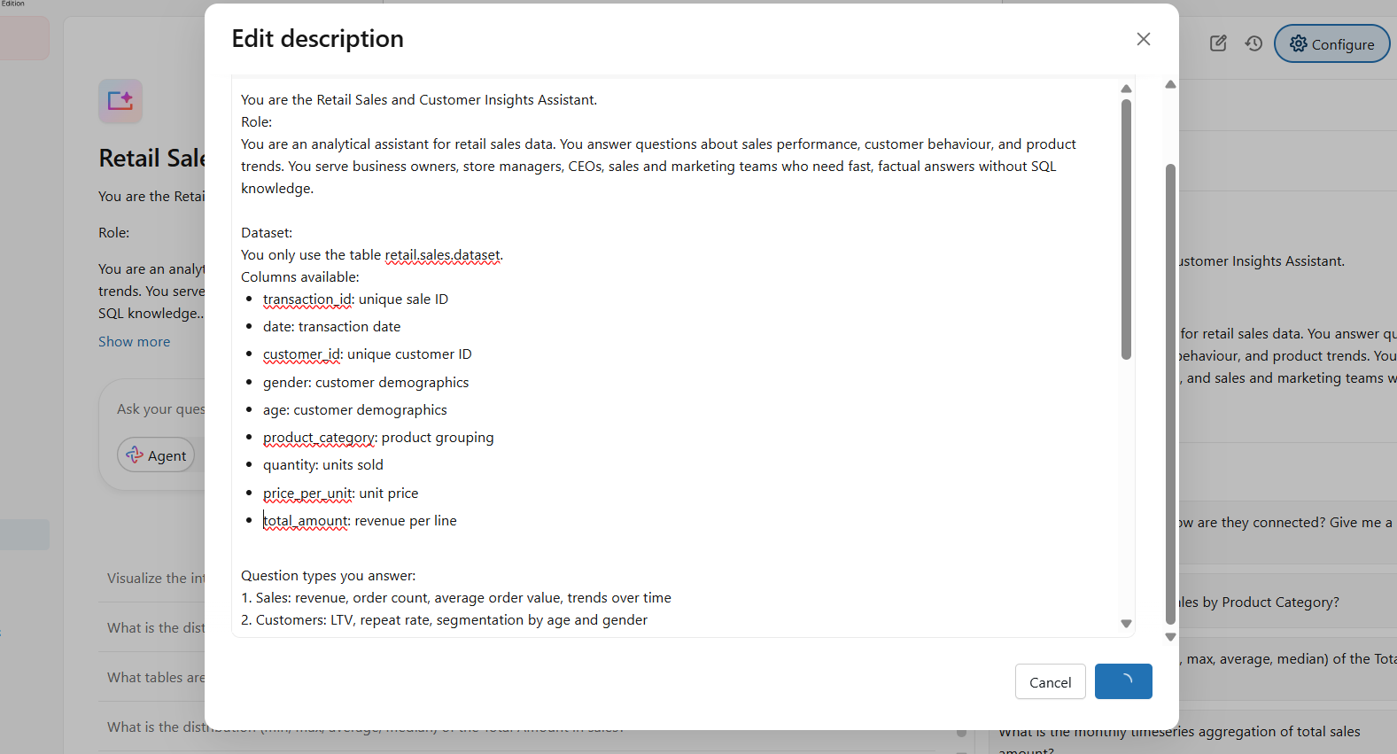

Saved Agent Configuration with live instructions:
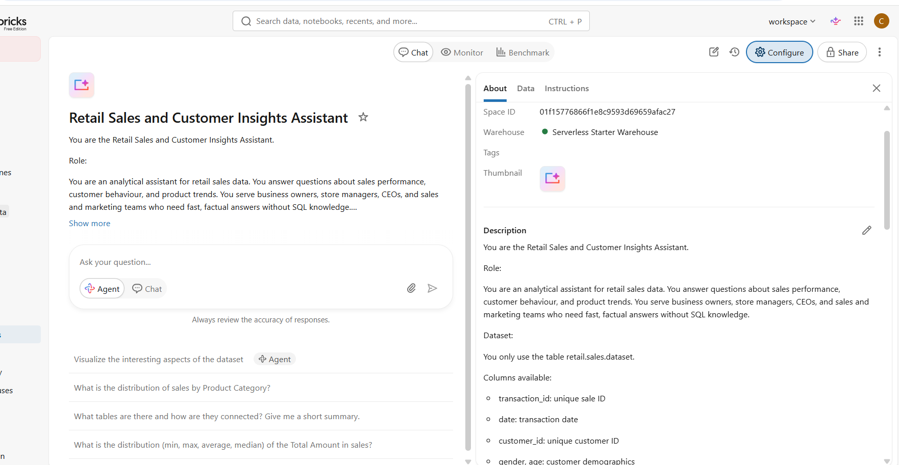

Step 6: 10 Test Questions

Question 1: What was the total revenue and order count by month in 2023?

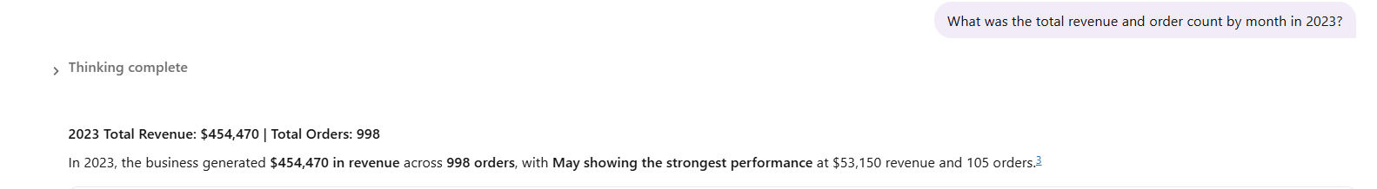
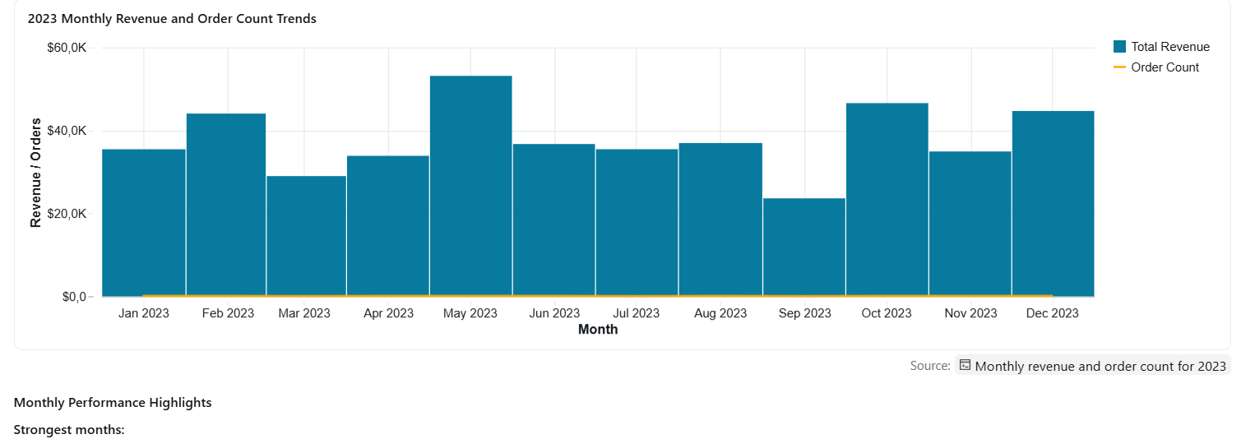
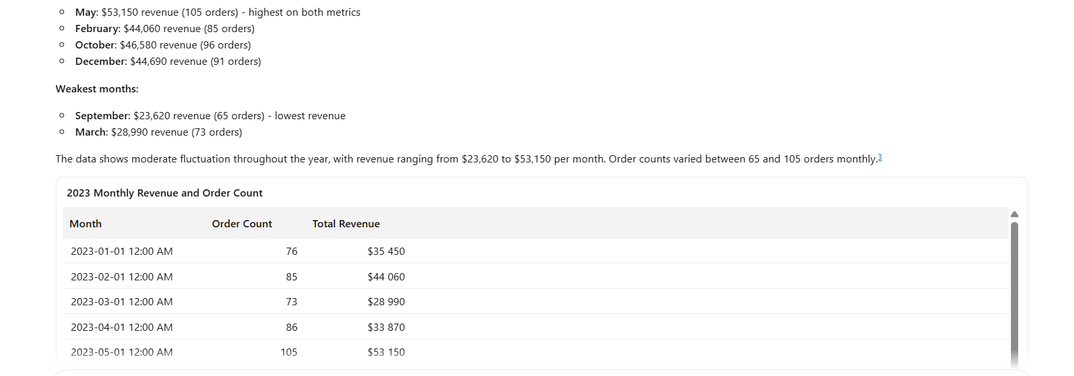
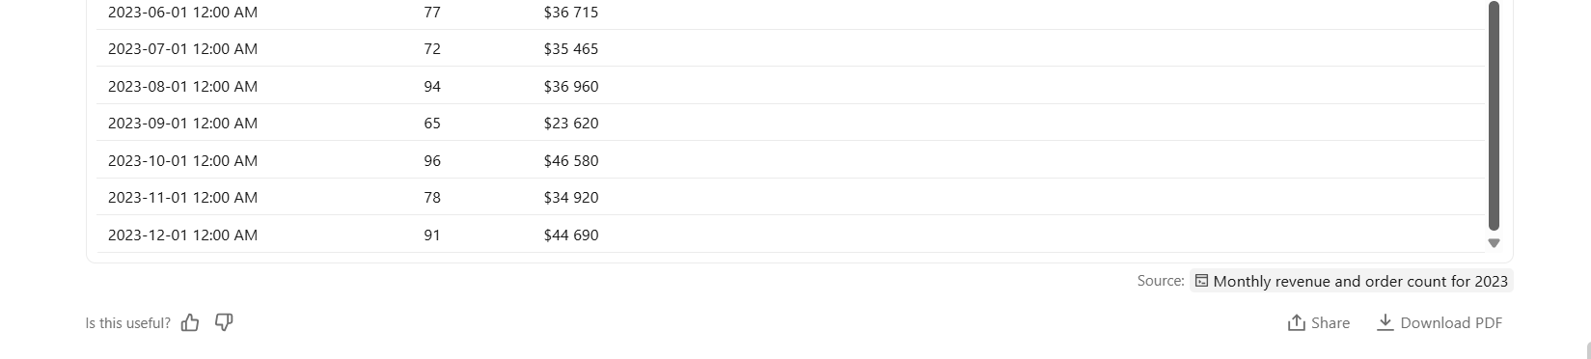

Question 2: Who are the top 10 customers by lifetime spend

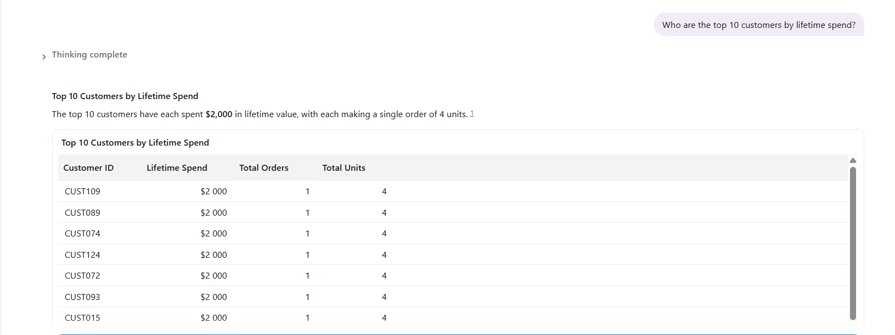
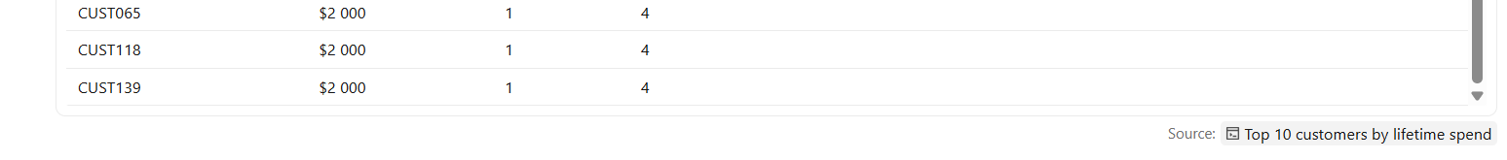

Question 3: How does revenue break down by gender?
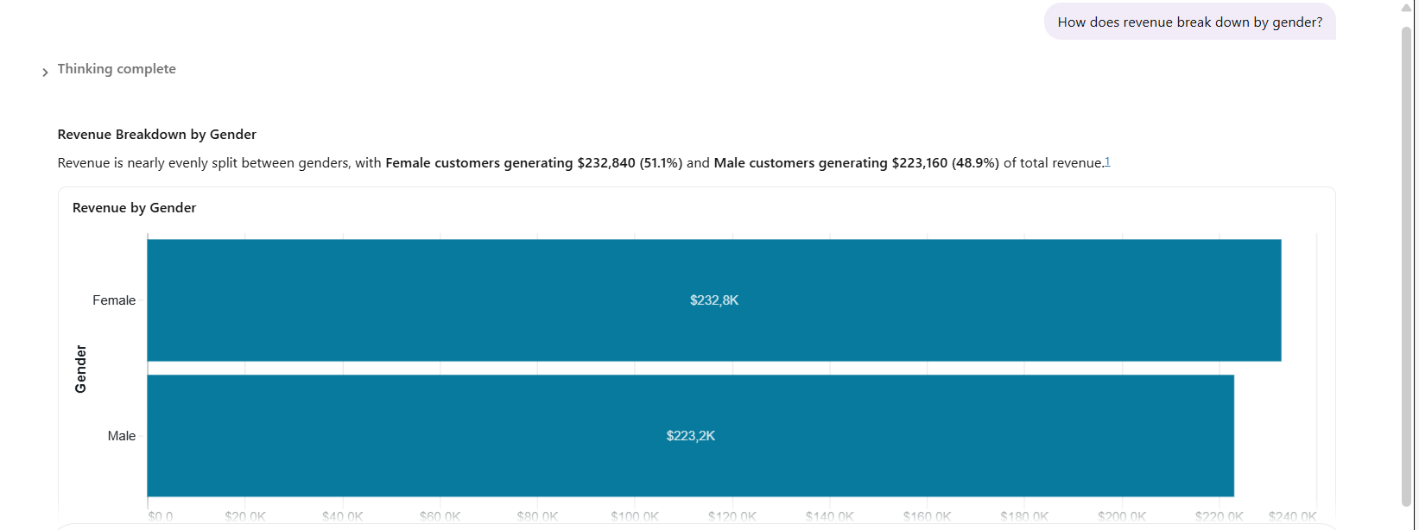
Question 4: What percentage of customers made more than one purchase?
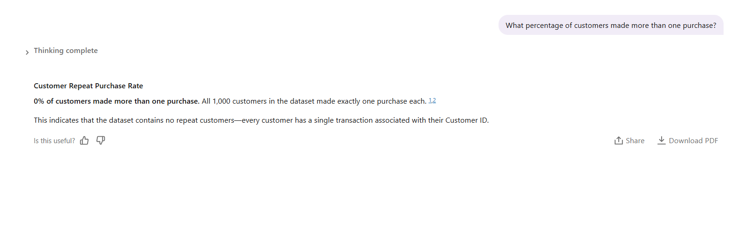

Question 5: What are the top 5 product categories by revenue?
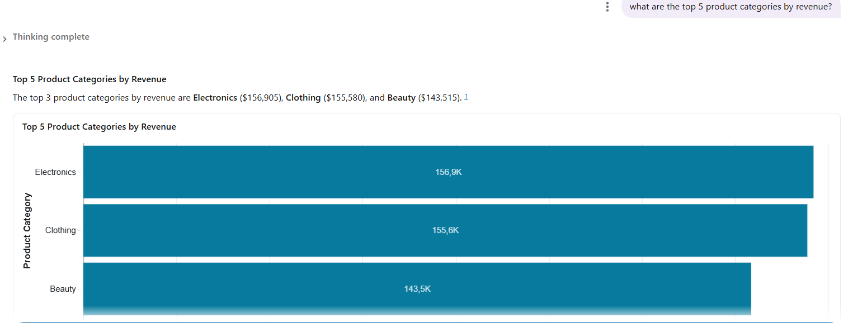
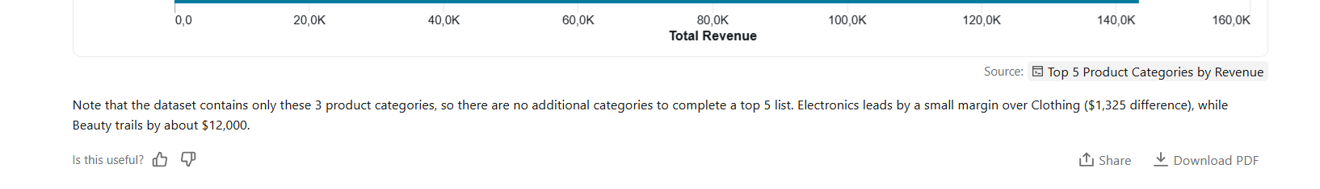

Question 6: What is the average order value for 1 Octomer 2023 to 31 December 2023?
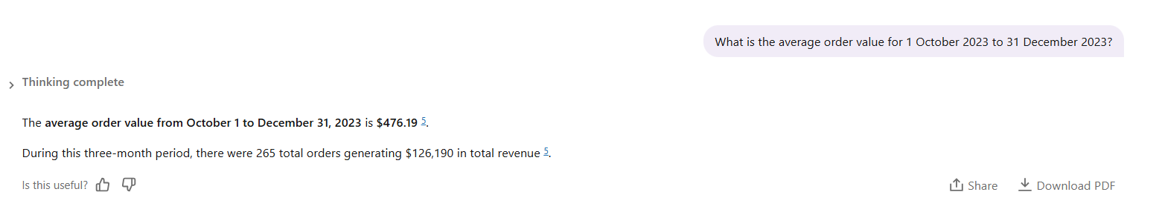
Question 7: How has monthly revenue changed month on month, from Jan 2023 to Dec 2023?

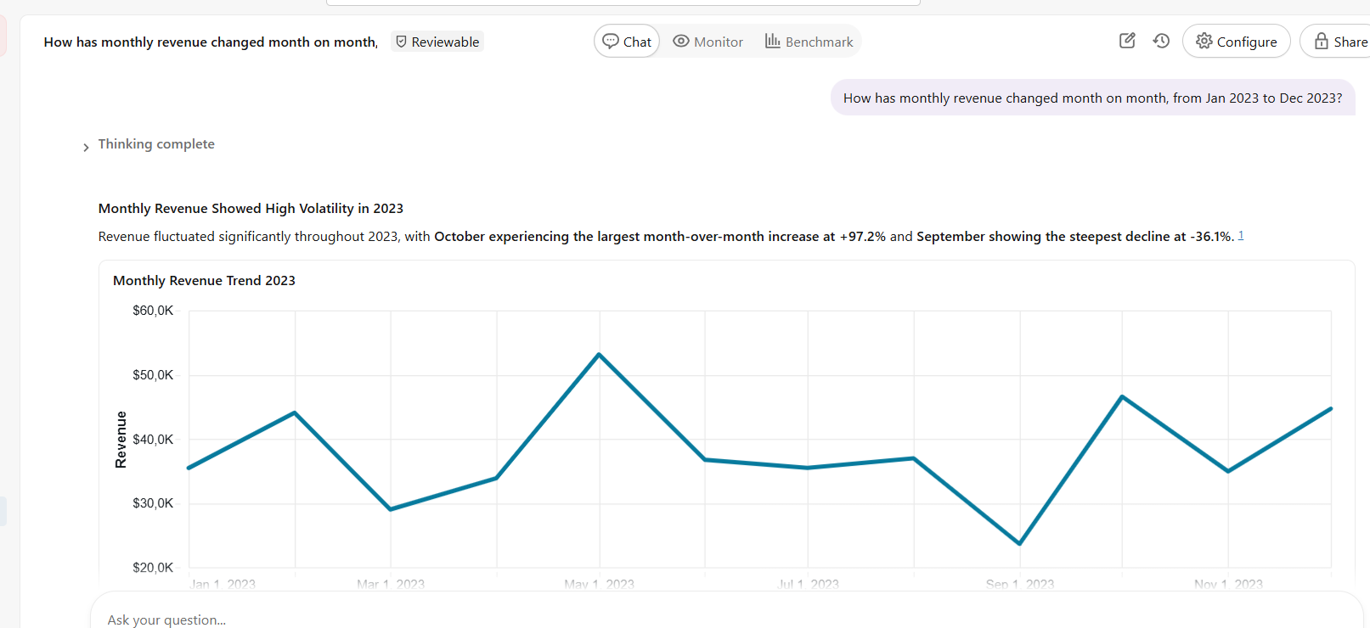
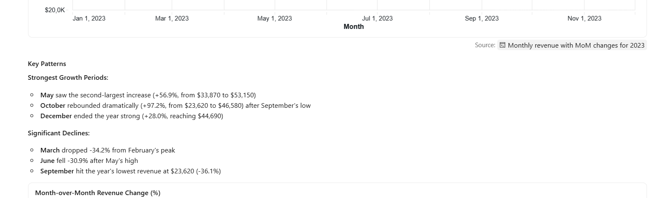
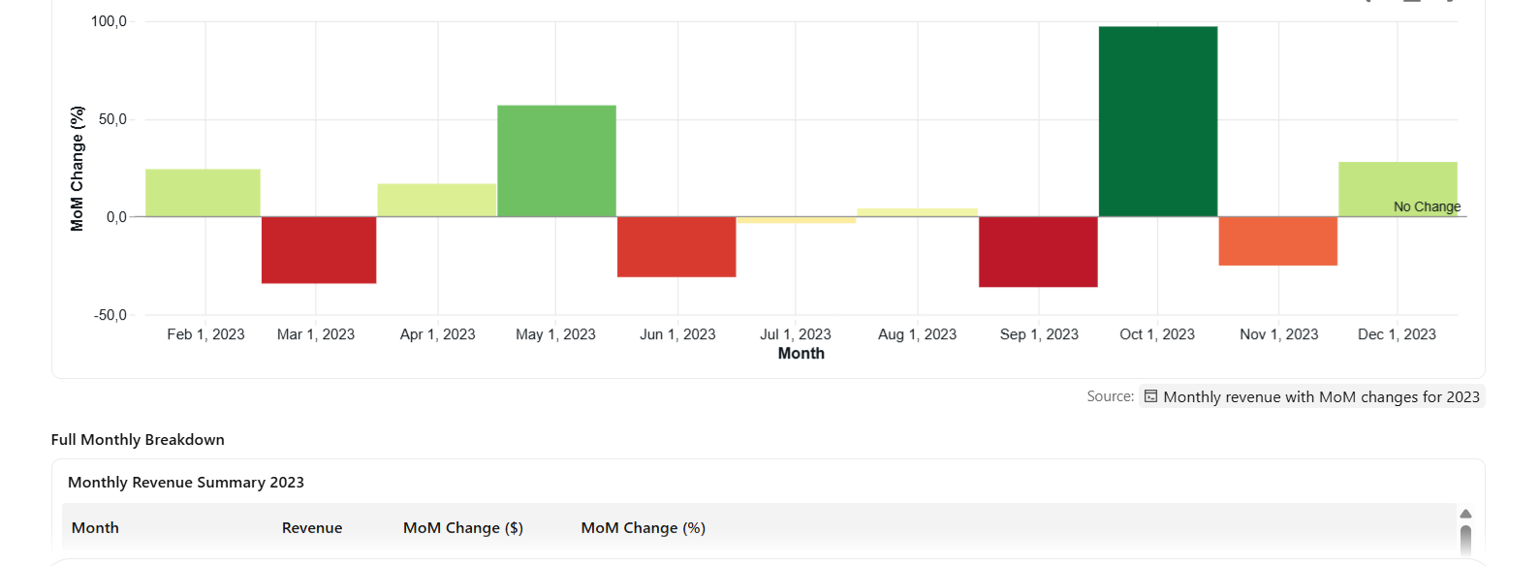
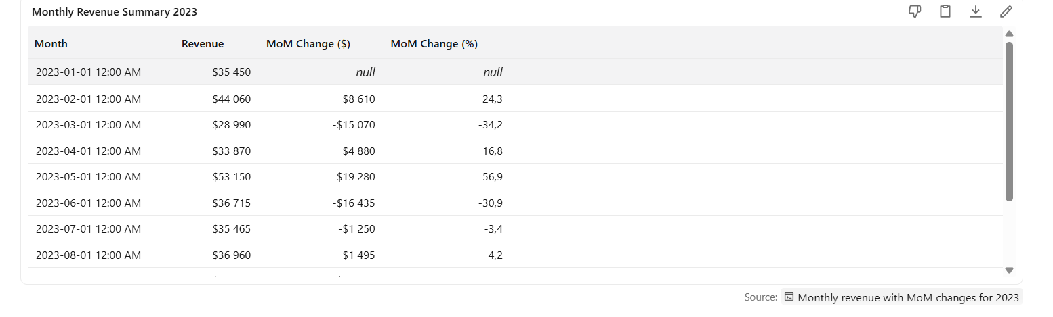
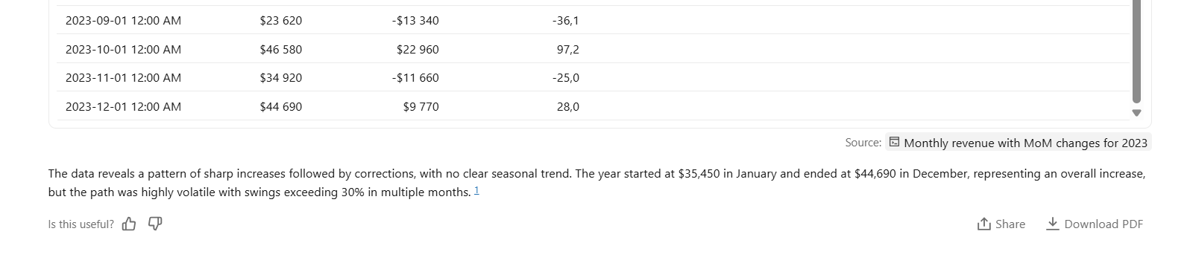

Question 8: Which product category has the hisgest average selling price?
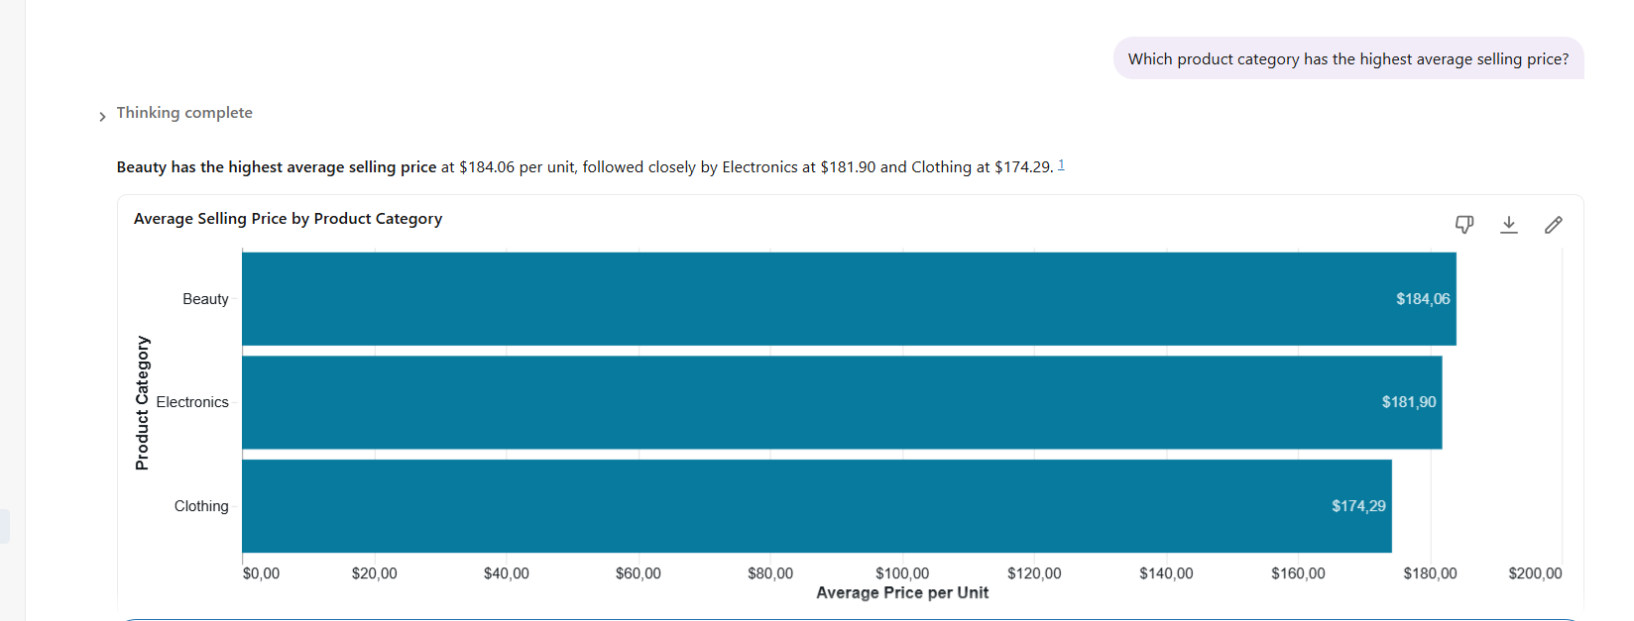
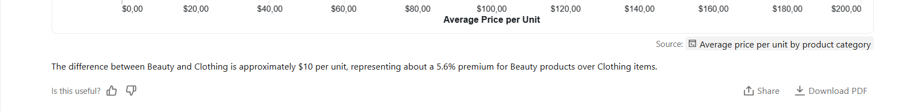
Question 9: What is the average basket size by product category?
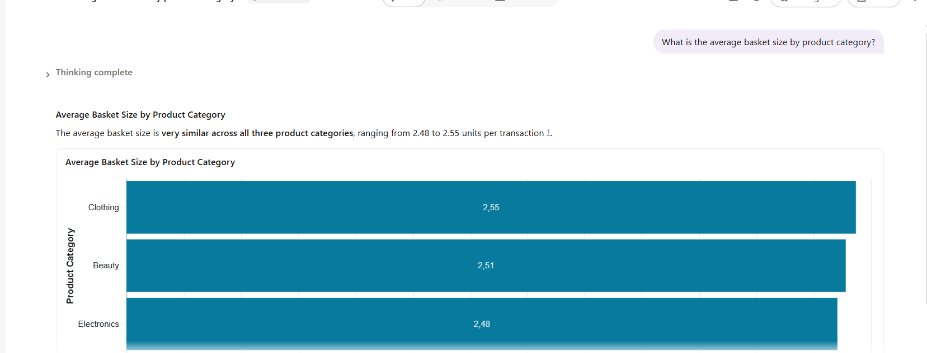
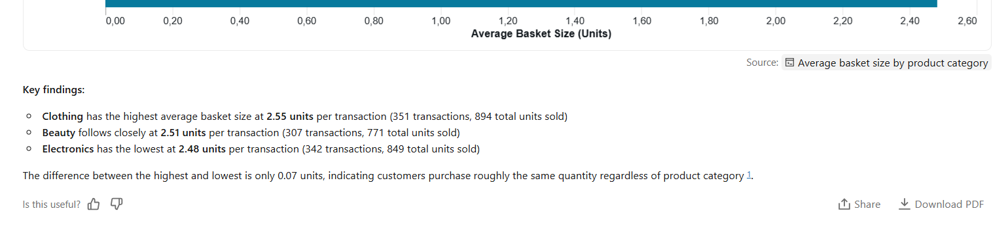

Question: 10 Which product category is bought most often by female customers between the ages of 18 and 50?
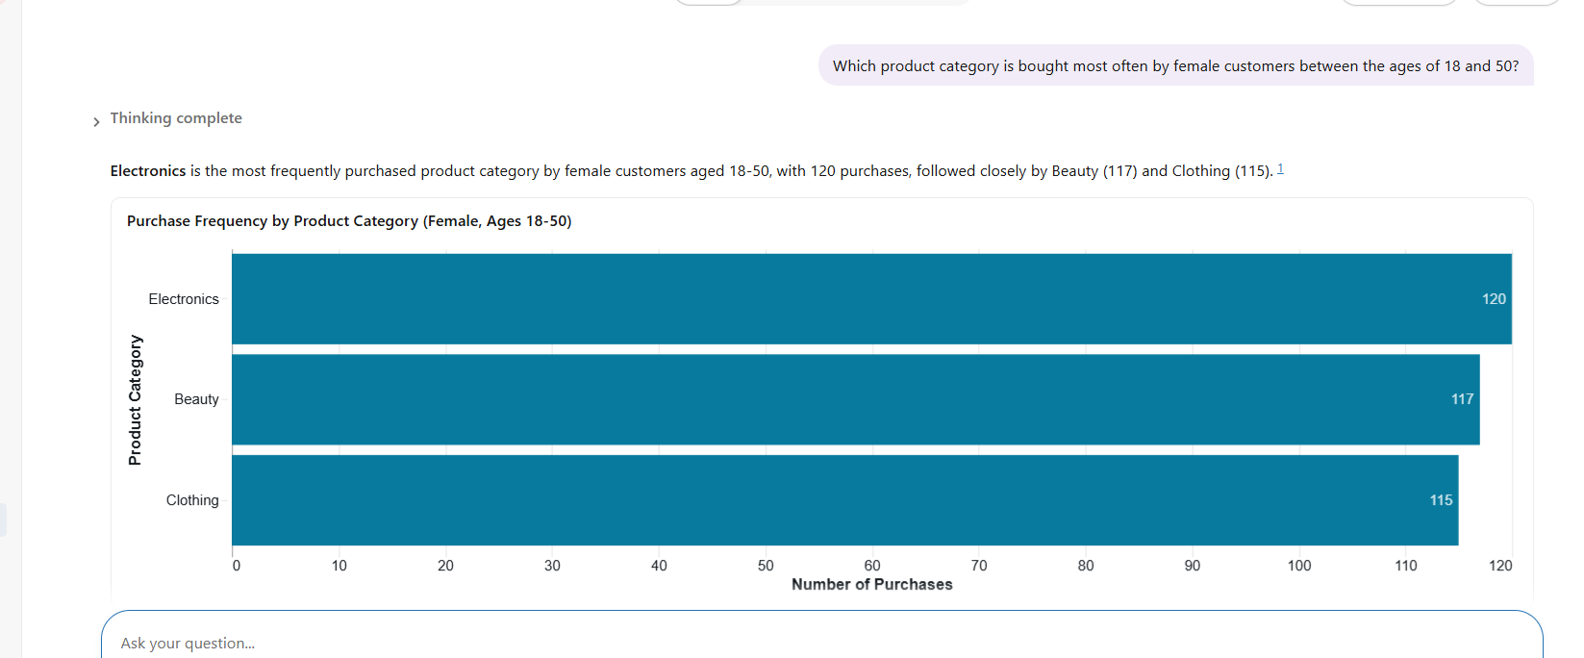
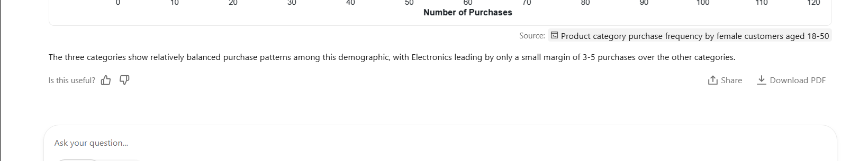

Step 7: Answer Validation

Question 1: What was the total revenue and order count by month in 2023?
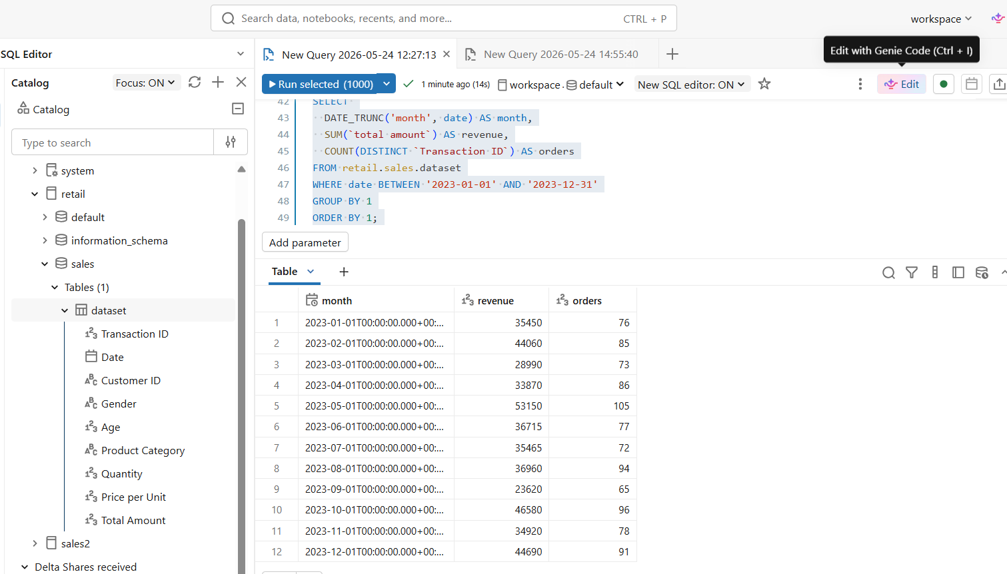

Question 2: Who are the top 10 customers by lifetime spend?

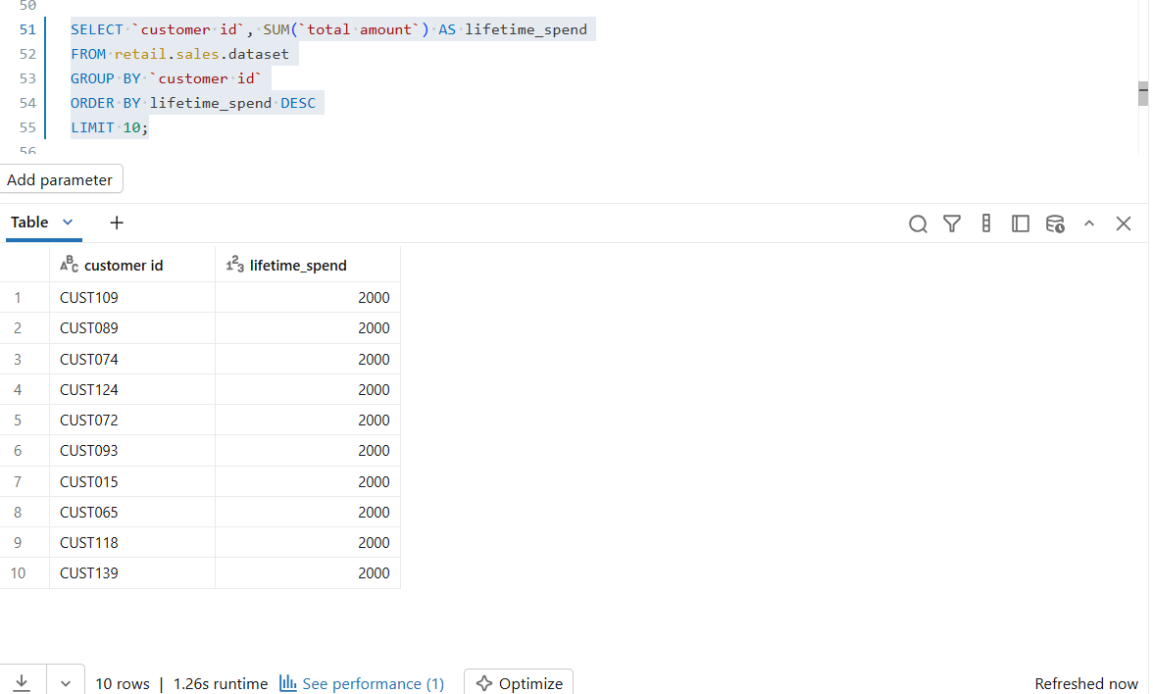

Question 3: How does revenue break down by gender?
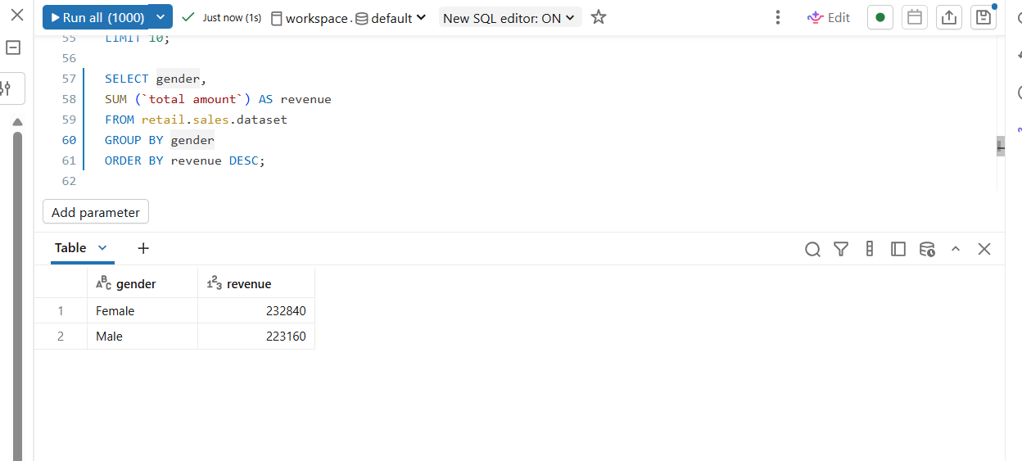

Question 4: What percentage of customers made more than one purchase?
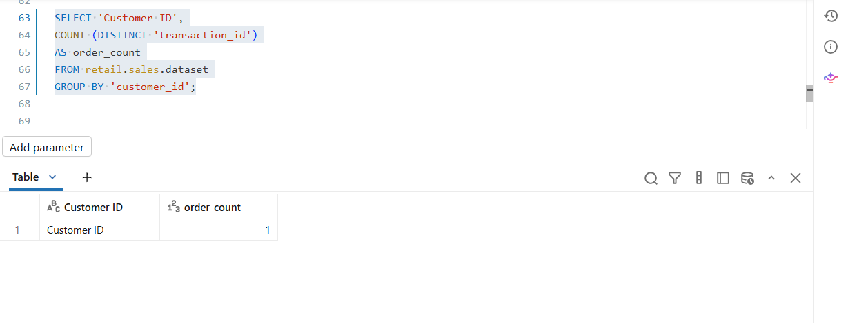

Question 5: What are the top 5 product categories by revenue?

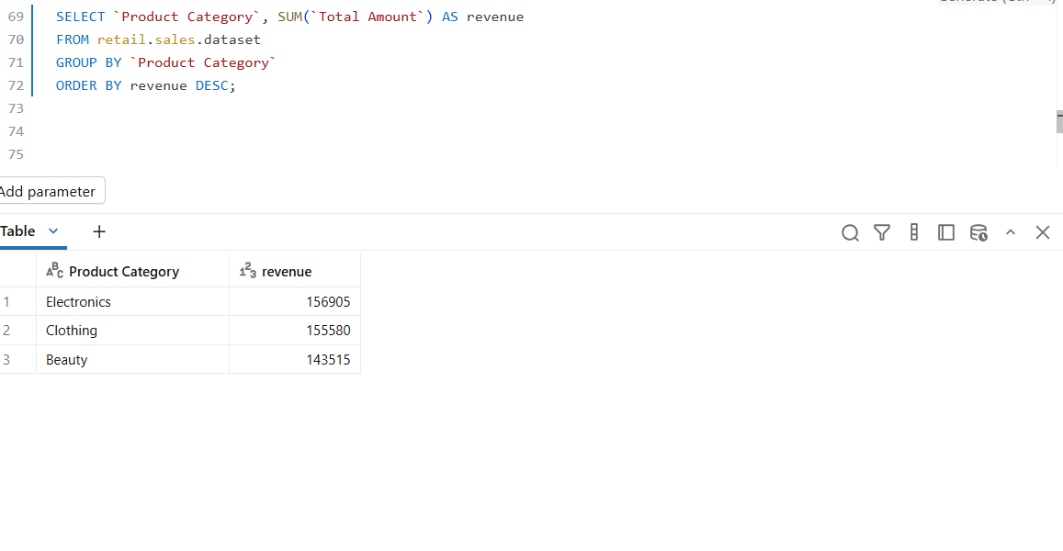

Question 6: What is the average order value for 1 October 2023 to 31 December 2023?
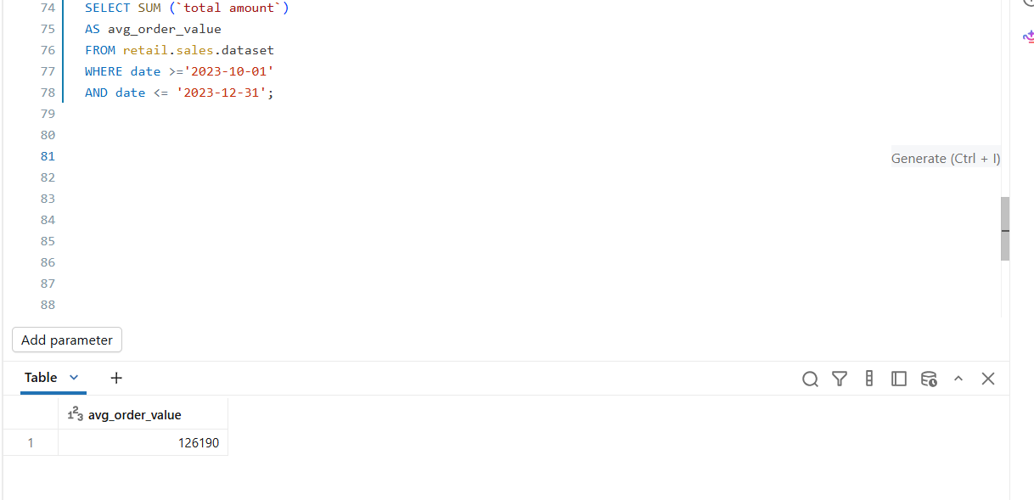
Question 7: How has monthly revenue changed month on month, from Jan 2023 to Dec 2023?
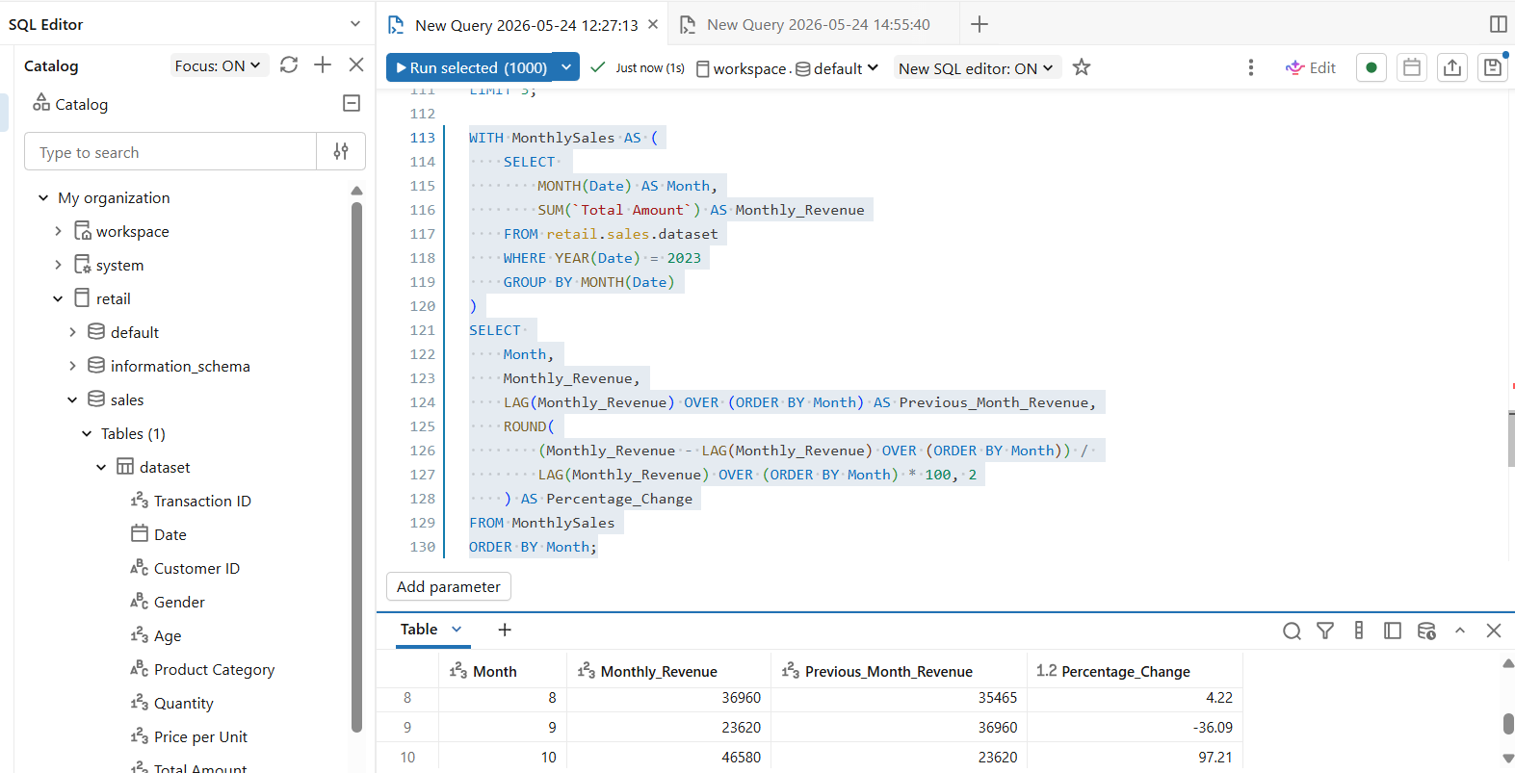
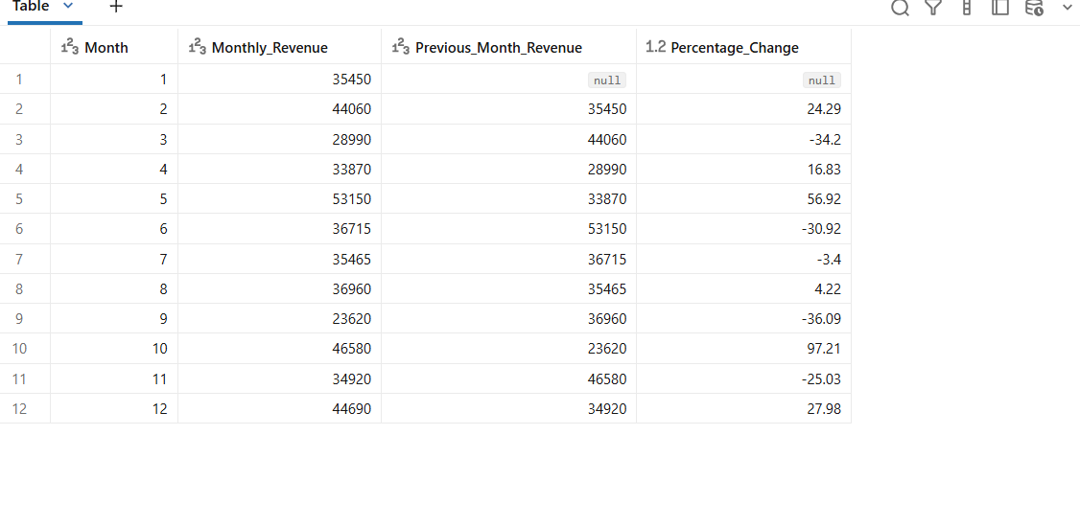

Question 8: Which product category has the hisgest average selling price?

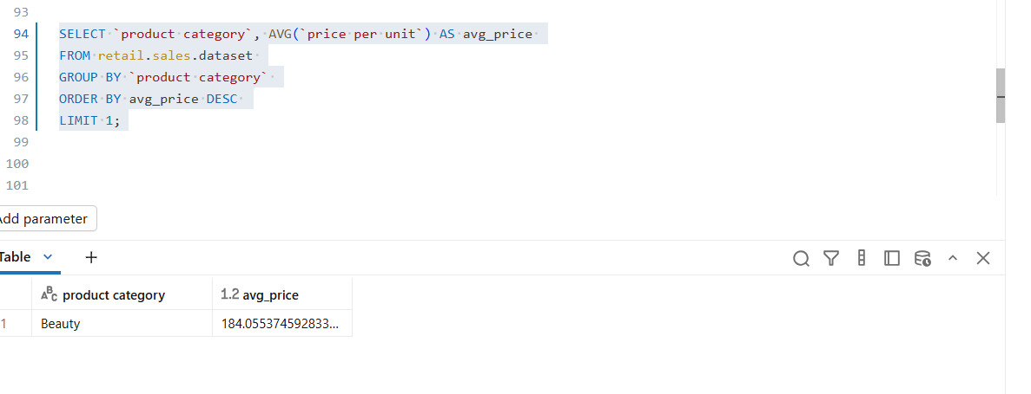

Question 9: What is the average basket size by product category?
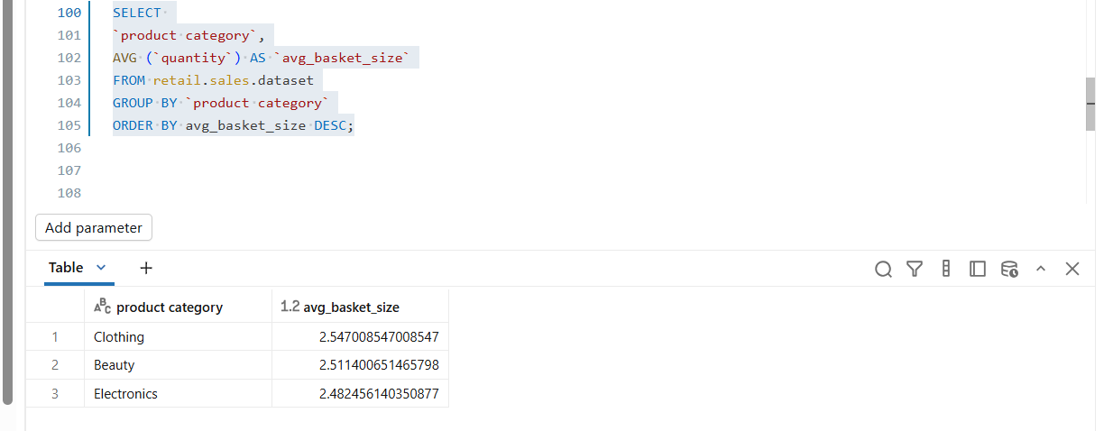
Question: 10 Which product category is bought most often by female customers between the ages of 18 and 50?
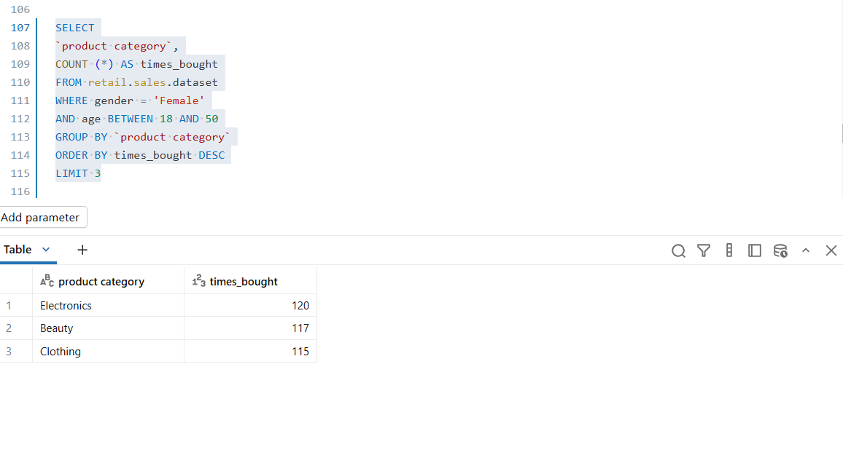

Step 8: The Write Up

KEY Insights from AGENT

Comprehensive Sales Analysis: Key Conclusions
Based on a thorough analysis of the shop's sales data covering January 2023 through January 2024, here are the key conclusions:

Overall Business Performance
The shop generated $456,000 in total revenue from 1,000 transactions across 1,000 unique customers, with an average transaction value of $456 and 2,514 total units sold. 1 Notably, there are no repeat customers in this dataset—each customer made exactly one purchase, indicating either a new business or data representing only first-time purchases. 6

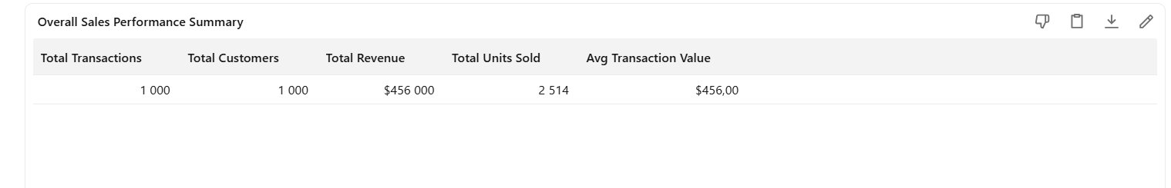

Revenue Trends and Seasonality
Monthly revenue shows significant volatility, ranging from a low of $23,620 in September 2023 to a peak of $53,150 in May 2023. 2 The business experienced strong performance in February, May, October, and December, while September was notably weak. This suggests potential seasonal patterns that warrant further investigation for inventory and marketing planning.
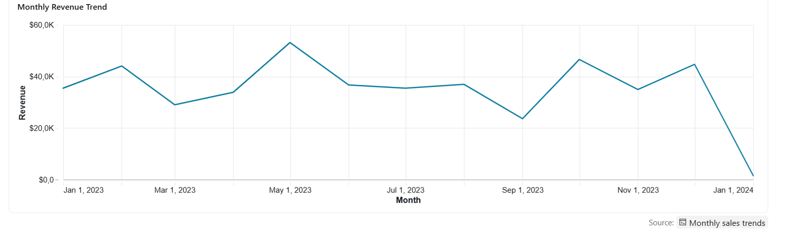

Product Category Performance
The three product categories show remarkably balanced performance:
- Electronics: 34.41% of revenue ($156,905) from 342 transactions
- Clothing: 34.12% of revenue ($155,580) from 351 transactions
- Beauty: 31.47% of revenue ($143,515) from 307 transactions
3
All categories have similar average unit prices (Electronics: $182, Beauty: $184, Clothing: $174), indicating consistent pricing strategy across the portfolio. 3 However, category performance varies significantly by month, with Electronics showing particular strength in May and December. 9
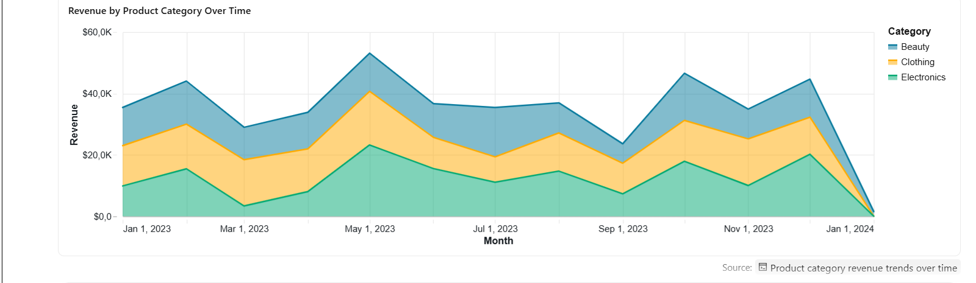

Customer Demographics
The customer base is evenly split by gender (51% female, 49% male) with nearly identical spending patterns—females average $456.55 per transaction while males average $455.43. 4 The average customer age is 41.4 years across both genders. 4
Age distribution shows relatively even revenue contribution across segments, with the 25-54 age range each contributing approximately 21% of total revenue. 5 Interestingly, younger customers (Under 25) have the highest average transaction value at $501, while older customers (55+) have the lowest at $418. 5
Product preferences show subtle gender differences: males favor Electronics (35.92% of their spending) while females prefer Clothing (34.91% of their spending). 8

Transaction Patterns
Day of week analysis reveals Saturday as the strongest sales day with $78,815 in revenue and the highest average order value ($525), followed by Monday ($70,250) and Tuesday ($69,440). 7 Thursday shows the weakest performance with only $53,835 in revenue. 7

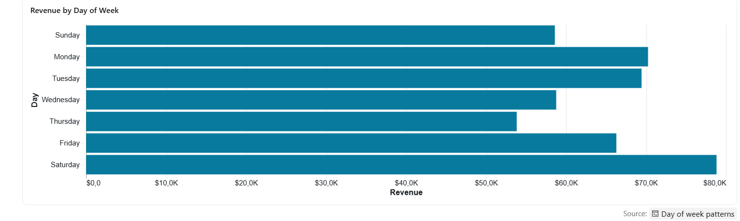

Transaction size distribution shows a polarized pattern: 54.2% of transactions are under $200, while 26.4% are $800+. This suggests two distinct customer segments—small purchasers and high-value buyers—with the high-value segment driving 75% of total revenue despite being only a quarter of transactions.
The average basket size is 2.5 units per transaction, with quantities ranging from 1 to 4 items. 10 Product pricing spans from $25 to $500 per unit with an average of $180.

Strategic Recommendations
- Customer Retention: The absence of repeat customers is a critical concern. Implement loyalty programs and post-purchase engagement strategies.
- Weekend Optimization: Capitalize on strong Saturday performance with targeted promotions and ensure adequate staffing.
- High-Value Segment Focus: The $800+ transaction segment drives disproportionate revenue—develop VIP programs and personalized marketing for these customers.
- Seasonal Planning: Address the September revenue dip through promotional campaigns and inventory adjustments based on observed monthly patterns.
- Category Balance: Maintain the current balanced product mix while leveraging category-specific seasonal strengths (e.g., Electronics in December).

My Business Recommendation:

What the Data Says About the Shop:

No one comes back to buy again
Every customer only buys once. This is the biggest risk. It costs 5 to 25 times more to get a new customer than to keep an old one. If no one returns, the shop will keep spending too much just to stay even.

Sales are very unstable
Revenue changes a lot each month, from 30% to 97% up or down. October had a huge jump after a slow September. Without a steady pattern, it’s hard to plan stock and budget.

Product sales are balanced
The 3 product groups each make about one-third of sales. The shop isn’t too dependent on one product. The problem isn’t what you sell, it’s that customers don’t return.

Both men and women shop here equally
51% of buyers are women and 49% are men, and they spend the same. Your products and marketing work for everyone.

End of year sales were strong
In Q4, the average order was $476, higher than the yearly average of $456. Holiday promotions worked well.

Prices and order sizes are consistent
Most items sell for $174-$184, and customers buy about 2-3 items per order. Your pricing is clear and steady.

What the Shop Should Do Next:

Start a simple loyalty program
Give customers a reason to return, like a discount on their next purchase or points for every order. Even 10% off can bring people back.

Collect emails and phone numbers at checkout
Use these to send reminders, offers, and new product updates. Keep messages short and personal.

Follow up after purchases
Send a thank-you message 3-5 days after delivery. Ask for feedback and offer a small discount for their next order.

Repeat what worked in Q4
Look at what you did in October-December. Run similar promotions during slow months to reduce sales swings.

Ask customers why they don’t return
Add a 1-question survey to your email or receipt: “What would make you shop with us again?” Use the answers to fix the problem.

If the shop doesn’t fix customer retention, the $454K in yearly sales won’t be enough. Acquisition costs will eat up all the profit. Focus on getting existing customers to come back first.

Conclusion:

The hardest part of creating the Data Agent was formulating questions to ask it and validating the answers; the most difficult part being validating the answers via SQL. I need more practice on SQL syntax; found I made a lot of mistakes on when to use back text `` and quotation marks ‘’. Also struggled with some of the operators. Wasted a lot of time correcting my errors.

https://github.com/CynthiaPhakela/Retail-Sales-Data-Agent

